

**Hunter Huss High School**

** “**Make Your Mark**”**

**AUGUST 2017 NEWSLETTER**

**The mission of Hunter Huss High School is to empower students to be lifelong learners and equip them to be successful members of society.**

1518 Edgefield Avenue, Gastonia, NC 28054

Tel: (704) 866-6610 Fax: (704) 866-6103

***Howling Huskies Newsletter***

Welcome back Huskies for the 2017-2018 School Year.  We are excited about our upcoming school year. New, this fall will include a newsletter that contains upcoming events at Hunter Huss for students, parents, staff, and community members.  Each monthly publication will include school news, home athletic events and academic updates. Newsletters will be emailed out every month around the 5th of the Month.

***Welcome New Staff…***

The Huskies staff is pleased to welcome the following new staff members for the 2017-2018 school year.

Nicholas Corbett- Math

Madison Capps-Math

Sarah Chase-Health Sciences

Elizabeth Garced-Exceptional Children

Bethany Heavner- Social Studies

Jessica Millwood-Exceptional Children

Stephanie Scism-English

Lindsay Taylor-Exceptional Children

Amy Wooten-Advanced Manufacturing

***Summer Hours…***

The office will continue summer hours 7:00-6:00 Monday through Thursday, until August 10th.  Beginning August 14th, the office will be open Monday - Friday.

***2017-2018 HUSKIE ATTIRE***

*Update your “Huskie” Wardrobe with new apparel available in the front office.  Stop by and see Ms. Biggerstaff for details.*

***Freshman Transition Camp***

Freshman Transition Camp will be held on **August 16th from 11:00-3:00**.  Lunch will be provided along with a freshman t-shirt.   Signups are available on the school website and Hunter Huss’s Facebook page.

**August Events**

8/7-8/8/17: Teaching & Learning Conference (Teachers)

8/3/17:  School Improvement Team Retreat

8/15/17:  Volleyball vs. Cherryville

8/16/17: Freshman Transition Camp

8/17/17: Staff Beginning of Year Meeting & Breakfast

JV Football vs. Patton

8/18/17: Volleyball vs. Highland

8/24/17: Open House at HHHS 1:00-6:00 pm

Volleyball vs. Piedmont Charter

8/25/17: Varsity Football vs. Cox Mil

**8/28/17:  First Day of School**

8/29/17: Women’s Tennis vs. E. Gaston

8/30/17:  Boys Soccer vs. N. Lincoln

8/31/17::  Volleyball vs. Burns

JV. Football vs. Clover

***New Program Areas***

We are pleased to offer two new program areas beginning in fall of 2017 within the Career Academy.  Biotechnology will be transitioning to Horticulture 1 and Horticulture 2 with a focus on Landscape Design.  We were also fortunate enough to be one of the recipients of the Golden Leaf Grant that will allow Hunter Huss to expand its courses to include Advanced Manufacturing 1 and 2.  Ms. Amy Wooten will be joining Hunter Huss from a long career with Mann & Hummel to start our Advanced Manufacturing program.  Mr. Michael Hatcher will continue to develop the Horticulture Program.  These programs will prepare students for many exciting career opportunities that are available locally in Gaston County and globally.

***Open House***

Open House will be held **Thursday August 24 from 1:00-6:00** for all grade levels.  There will be an informational meeting at 6:00 in the auditorium. Make sure to stop by and visit with your teachers for the next year.

***2017-2018 Career Focused Curriculum***

The question that is always asked, “What do you want to be when you grow up?”  Surprisingly, most people cannot answer that question.  Beginning fall 2017, all incoming freshman will begin their high school experience with a course devoted to exploring their career options.  Students enrolled in this Career Management course will have the opportunity to earn an industry credential in soft-skills training.  This course will focus on career interest inventory, four-year planning of high school opportunities, interview skills, resume and portfolio development. Students will have the opportunity to complete an individualized 4-year plan focused on his or her chosen career goals.

***FCCLA Competes at National Competition***

Allen Grier, Essence Currence, and Tyzera Simon joined 9000 students and their chaperones, from across the United States for the Family Career and Community Leaders of America National Leadership Conference held in Nashville, Tennessee during the week of July 4. They qualified by winning a gold medal at the state competition and securing their spot in April.  The teams were slated with the task of creating an after workout snack that had 10g of protein.  Our Huskie team created Power Cakes, a protein power cake. Included in the competition was creation of the recipe, logo, packaging, nutritional label, and cooking instructions. The students had to present to a team of five judges and followed very strict presentation guidelines, including professional dress. In their down time, the team, along with Mrs. Hester took tour of the Nashville, spent the afternoon at a water park, visited some iconic sites like the Grand Ole Opry, local Triple D restaurants and rode bikes thru the city.  They were front row for the largest fireworks show in the United States. The students also attended a college fair, leadership seminars, and met students from all over NC, as well as the country. The students placed in the bronze medal category and returned with tons of new ideas for the upcoming year. If you have students interested in FCCLA for next year, please see Mrs. Hester.

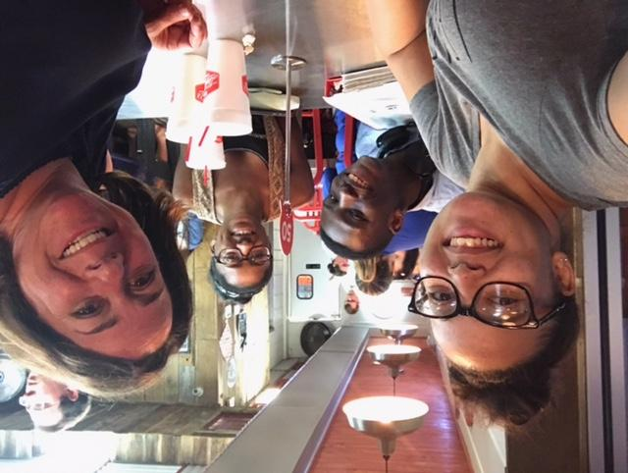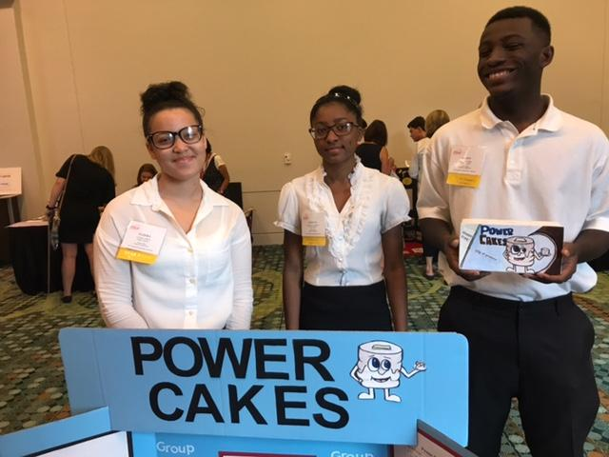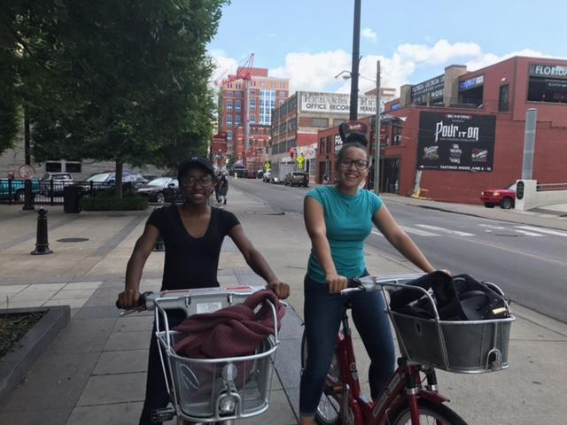

***2017-2018 Advisory Board***

Hunter Huss is looking for business leaders to serve on our advisory board beginning in August 2017.  The advisory board will meet several times a year and to discuss business needs within our community and steps that the career academy can implement to prepare our students to be competitive in today’s ever changing workforce. The first meeting will be held in late September, beginning with a breakfast at Hunter Huss and a tour of the Career and Technical Programs.  If you are interested in serving on this board of business leaders or need additional information, please email Ms. Willis at stwillis@gaston.k12.nc.us.

** #HUSKIENATION **